Partition of variation: an explanation and comparison of variance components analysis methods

Application of variance components analysis
Variance Components are used to estimates the contribution of each random effect to the variance of the dependent variable. To calculate variance table the levels of categorical random effect variables are assumed to be a random sample of all categories. Random effects might include grouping variables like store in a study of shoppers, weekday in a production yield study, or race in a repeated measures medical study.
Variance components can be calculated to identify sources of variation that can be eliminated to decrease output variation or to proof that a random effect has negligible contribution to output variation. Analytical process are typically designed so that the operator executing the analysis does not influence the resulting quantitation and this needs to be validated.

History of variance components analysis
Various variance components analysis methods are available. Recognized techniques are Expected Mean Square (1921), Maximum Likelihood (early 1800), Restricted Maximum Likelihood (1937), Bayesian variance components estimation. Most of these techniques predate the invention of the computer and have not changed much with the advent of near unlimited computational power. Restricted maximum likelihood is currently the advised standard in most guidance from United States Pharmacopeia, whereas NIST uses Expected Mean Squares. POV was invented by Thomas A. Little in 1993 for the analysis of semiconductor data for hard drive manufacturing. In 2015 Thomas A. Little and Paul Deen collaborated on expanding the functionality of the POV engine with a full suite of Measurement System Analysis (MSA) tools. The POV engine is currently publicly available as a JSL script for use in JMP statistical software from SAS and can be found on the website https://thomasalittleconsulting.com. A package for R statistical software has been developed in 2020 by Paul Deen and is available from CRAN.

Technical description of POV
both the response mean and standard deviations change (are variable). The variation in the means and the variation of the standard deviations are two components of the total variation. The first is the between variation and the second is the within variation.
Change in Mean is Between factor variance
Change in StdDev is Within factor variance
Common variance it the minimum amount of variance present in all unique combinations of factor levels.
In the case of a 2 factor crossed study the possible combinations are:

Machine A
Machine B
Machine C
Metrology A
Metrology B
Metrology C
Figure 4 Crossed factor structure
The possible variance components are:
$${SD}_{Overall}=\sqrt{\begin{aligned}{SD}_{Between Machine}^{2}+{SD}_{Between Metrology}^{2}+{SD}_{Between Machine*Metrology}^{2}+ {SD}_{Within Machine}^{2}+ \\ {SD}_{Within Metrology}^{2}+{SD}_{Within Machine*Metrology}^{2}+ {SD}_{Common}^{2} \end{aligned}}$$

The POV method is explained with an example using JMP by SAS. The example contains one response and the factors Machine and Metrology. A quick view of the data is provided in three graphs:
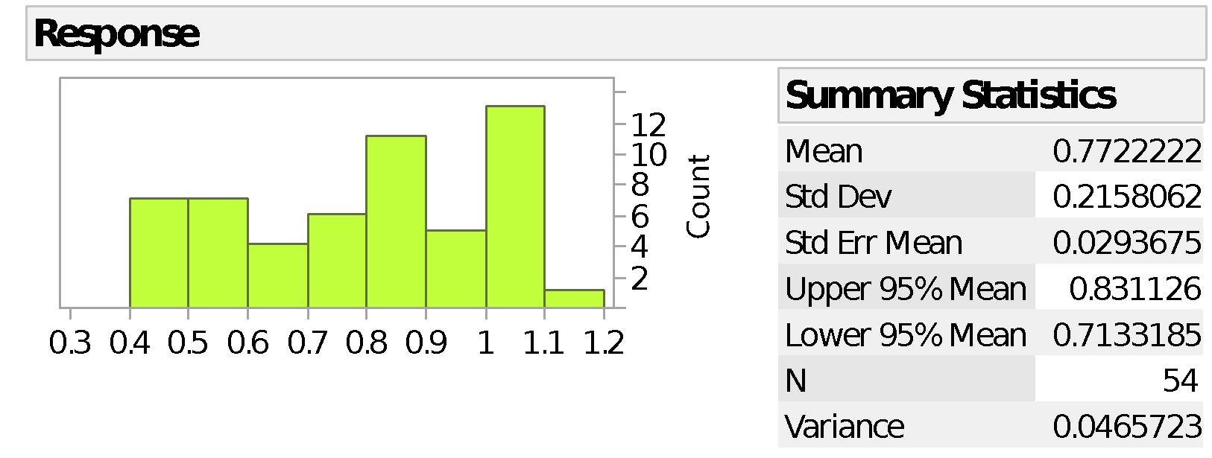
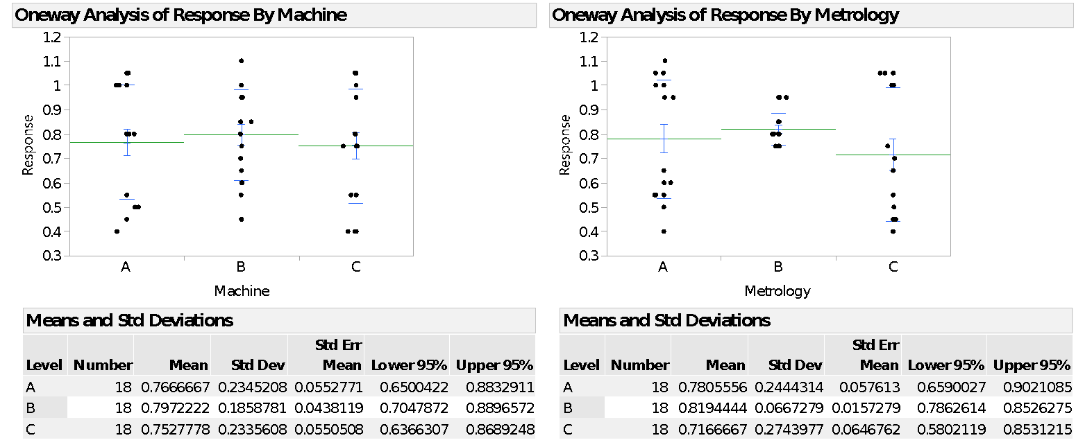
Figure 5 Three part data overview
POV uses generalized linear regression in the fit model platform, to calculate the sum of squares for the model and the error. These are used to assign the observed total variance to the between and the within components.
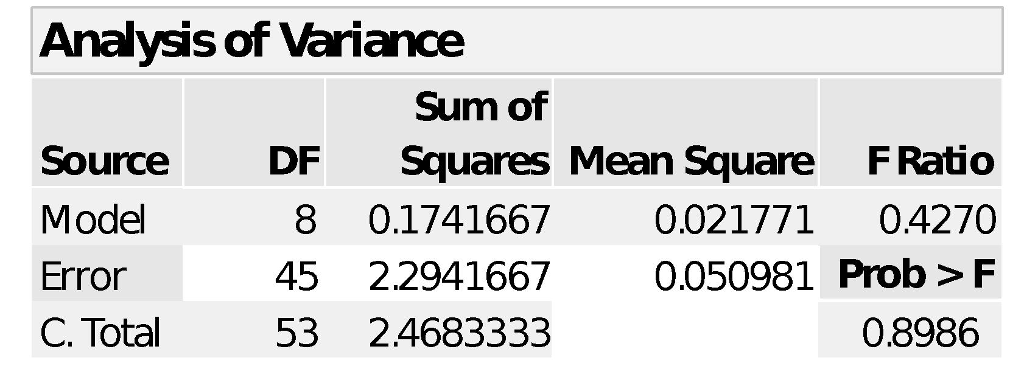
Table 1 Total ANOVA
$${Var}_{Between total}=\frac{{SS}_{Model}}{{SS}_{Total}}* {Var}_{Total}\frac{N-1}{N}= \frac{0.1741667}{2.4683334}*0.04571=0.003225$$
$${Var}_{Within total}=\frac{{SS}_{Error}}{{SS}_{Total}}* {Var}_{Total}\frac{N-1}{N}= \frac{2.294167}{2.4683334}*0.04571=0.042485$$
Then sequential sum of squares are used to calculate the between factor effects as a fraction of the total between variance.
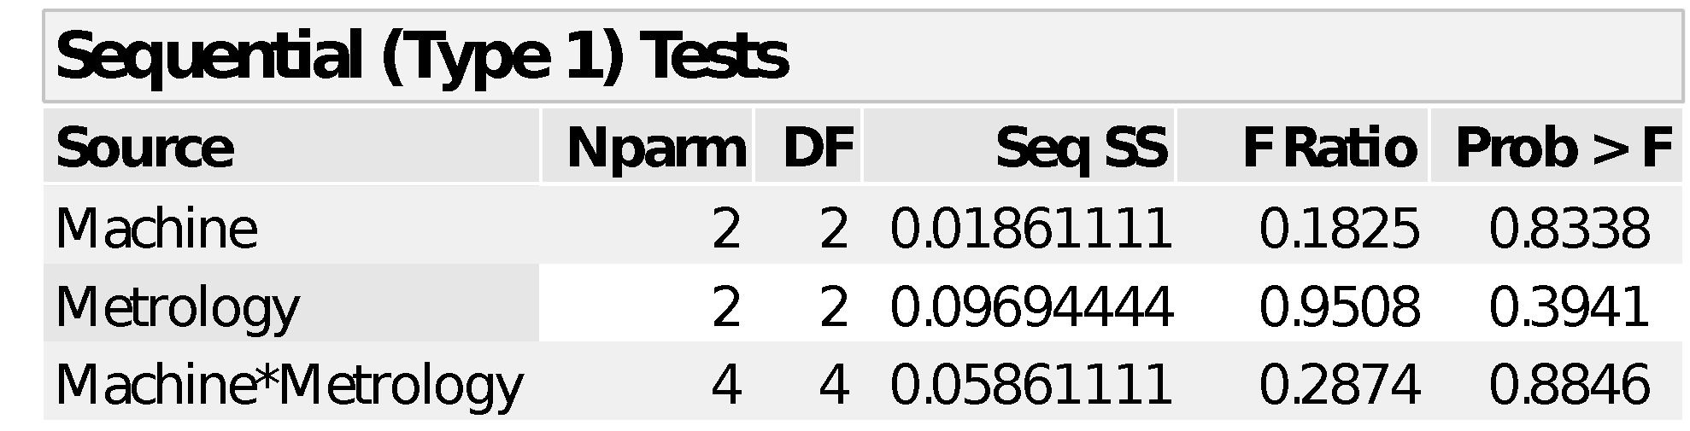
Table 2 Between ANOVA
$${Var}_{Between Machine}=\frac{{SS}_{Machine}}{{SS}_{Total}}* {Var}_{Between Total}= \frac{0.01861111}{0.17416666}*0.003225=0.000345$$
$${Var}_{Between Metrology}=\frac{{SS}_{Metrology}}{{SS}_{Total}}* {Var}_{Between Total}= \frac{0.09694444}{0.174167}*0.003225=0.001795$$
$${Var}_{Between Machine*Metrology}=\frac{{SS}_{Machine*Metrology}}{{SS}_{Total}}* {Var}_{Between Total}= \frac{0.05861111}{0.174167}*0.003225=0.001085$$

The population variance for each unique combination of factor levels is calculated:
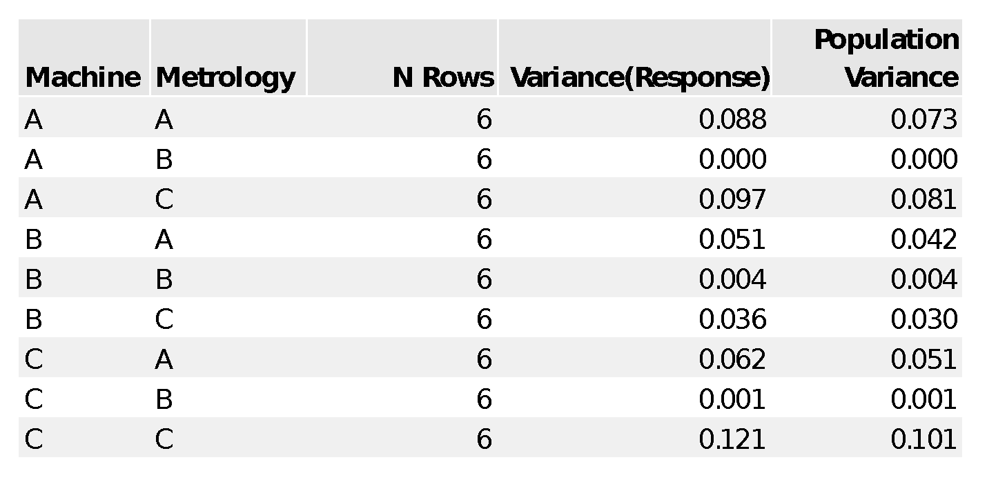
Table 3 Variance table
The common (minimum) variance is equal to 0 as defined by the combination of Machine A, and Metrology B.
Again the sequential sums of squares are used to calculate the within fractions of the total. Using the number of rows as frequency in generalized linear regression allows POV to handle unbalanced data sets.
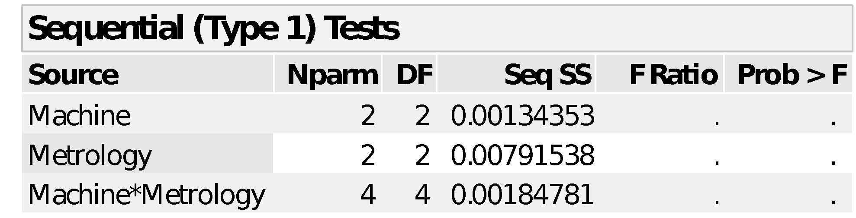
Table 4 Within ANOVA
The common variance is subtracted from the total within and the remainder is used for the within variance components.
$${Var}_{Within Machine}=\frac{{SS}_{Machine}}{{SS}_{Total}}* {(Var}_{Within Total}-{Var}_{Common})= \frac{0.00134353}{0.01110672}*0.042485=0.005139$$
$${Var}_{Within Metrology}=\frac{{SS}_{Metrology}}{{SS}_{Total}}*{(Var}_{Within Total}-{Var}_{Common})= \frac{0.00791538}{0.01110672}*0.042485=0.030277$$
$${Var}_{Within Machine*Metrology}=\frac{{SS}_{Machine*Metrology}}{{SS}_{Total}}* {(Var}_{Within Total}-{Var}_{Common})= \frac{0.00184781}{0.01110672}*0.042485=0.007068$$
The complete set of variance components are:
 | Variance | % of total | StdDev
Between Total | 0.003225 | 7.06 | 0.056792
Between Machine | 0.000345 | 0.75 | 0.018565
Between Metrology | 0.001795 | 3.93 | 0.042371
Between Machine*Metrology | 0.001085 | 2.37 | 0.032945
Within Total | 0.042485 | 92.94 | 0.206118
Within Machine | 0.005139 | 11.24 | 0.071688
Within Metrology | 0.030277 | 66.24 | 0.174004
Within Machine*Metrology | 0.007068 | 15.46 | 0.084072
Common | 0 | 0 | 0
Total | 0.04571 | 100 | 0.213799
Table 5 Variance components

Comparison of POV to REML

Restricted maximum likelihood (REML)
REML can analyze multi factorial data in balanced and unbalanced designs but it only provides a measurement of the between variance components and the sum of the within components. REML is a predictive technique that tries to describe the population with multiple variance components, the errors expand and it often predicts more variation than the observed sample contains.

Partition of Variation (POV)
POV is an exact method because it uses sums of squares to precisely quantify the sample variance components.
POV and REML were both applied to a simulated data set and the results are made available for comparison.
Figure 7 Test of means for sum of between components
It can be seen that the between variance components are on average bigger when using the REML method versus the POV method. ANOVA with a pooled t-test tells us this is a significant difference where REML is on average 0.58 bigger (95%CI 0.096-1.072) than POV. Since REML components do not follow a normal distribution we use Levene test for unequal variation and conclude that the variation is equal.

Figure 8 Visualizing the between components at different factor combinations
When the effect is large, REML estimates bigger variance components than POV. When the effect is small REML estimates smaller variance components. The most blatant example of this is the Component=Day, Sample=2, Concentration=150 where REML produces a zero result which does not match the simulation equations. POV gets it right in that case.
The repeatability is the only part of the within components that can be compared between the two methods. The repeatability broken down by the factors looks like this:
Figure 12 The repeatability broken down by Concentration, Sample and Method
It can be seen that the repeatability is always bigger when using the REML method versus the POV method.

Recommendations and conclusions
Partition of Variation is a superior variance components calculation method.
- POV produces more insight because it fully parses the within variance components.
- POV is more reliable because the components do not over or underestimate like REML does.
- POV correctly reported all interaction terms that were missed by REML.
- Total variance is exactly the true observed variance meaning that POV produces and exact quantitation of all observed variation meaning that the variance components are exact as well.
POV variance components analysis gives numbers that are closer to the true group standard deviation and as such are a better description of the variance components. The between and within components are necessarily closer to the true values as well, in fact the usage of the sequential sums of squares in the calculation of POV guarantees and exact description of the variance components.
POV gives us more insight into the data by parsing out the within variation into its constituent components. REML does not break down the repeatability into its constituent components. If the need arises to improve process execution, understanding where the biggest sources of variation are is essential. By not parsing out the within variation, the ability to prioritize improvement efforts is lost.
Using POV there is less variance inflation making it a more reliable method in all three of the tested conditions. REML based analysis will regularly fail process qualification specification limits that are passed when POV is used.
Because of the exactness and completeness of the calculation, POV needs to become the standard for variance components estimation in most applications

References
NIST variance components https://www.itl.nist.gov/div898/handbook/prc/section4/prc44.htm
United States Pharmacopeia https://www.usp.org/
Bartlett, M. S. (1937). "Properties of Sufficiency and Statistical Tests". Proceedings of the Royal Society A: Mathematical, Physical and Engineering Sciences. 160 (901): 268. Bibcode:1937RSPSA.160..268B. doi:10.1098/rspa.1937.0109.
Patterson, H. D.; Thompson, R. (1971). "Recovery of inter-block information when block sizes are unequal". Biometrika. 58 (3): 545. doi:10.1093/biomet/58.3.545.

(Words: 1500-2000)

